2022 GoWest/ECONorthwest Sample Social Media Posts - Wyoming

WYOMING

Platform(s) | Message | Visual
Facebook | Cooperatives are part of the Wyoming way of life.  Credit Unions are comparable to  Wyoming’s 14 electric power distribution cooperatives. They are member-owned financial cooperatives in the state and operate in a similar fashion.  #CreditUnionDifference | 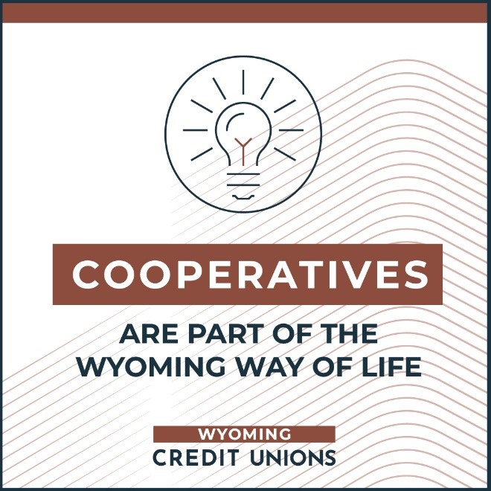
Facebook | More than 336,000 Wyomingites choose credit unions as their preferred financial services partner. Those members enjoyed $36 million in direct member benefits last year. #CreditUnionDifference! | 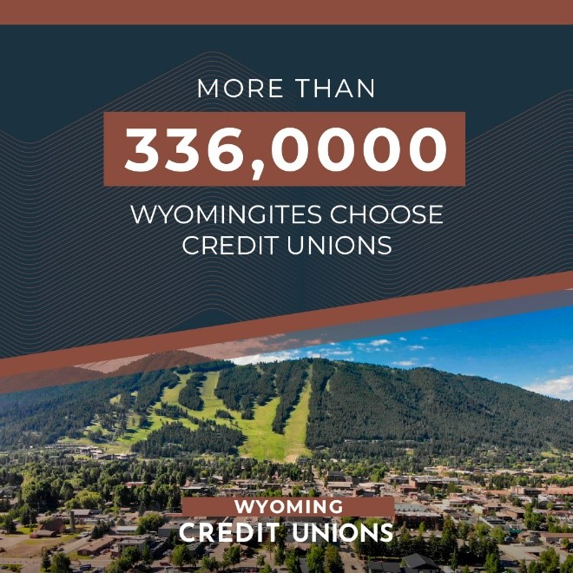
Facebook | Wyoming credit unions are dedicated to financial wellness for members and nonmembers, alike. More than 10,000 Wyomingites received financial education through the state’s credit unions.  #CreditUnionDifference! | 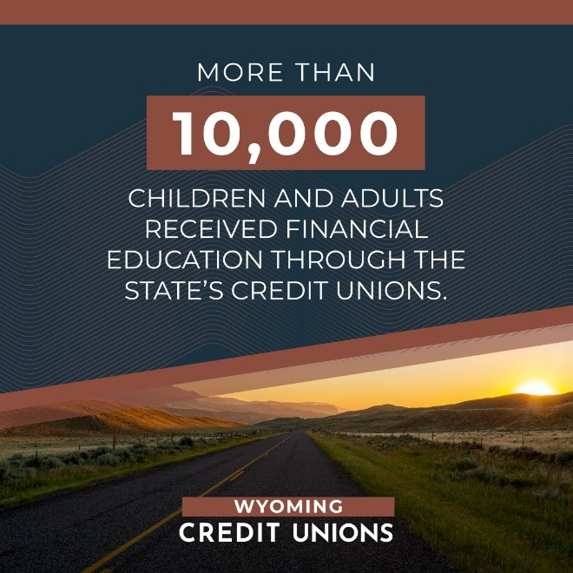
Facebook | Keeping Wyoming credit union members and their communities strong is part of our mission. Wyoming credit unions donated $521,000 to charitable causes last year. #CreditUnionDifference! | 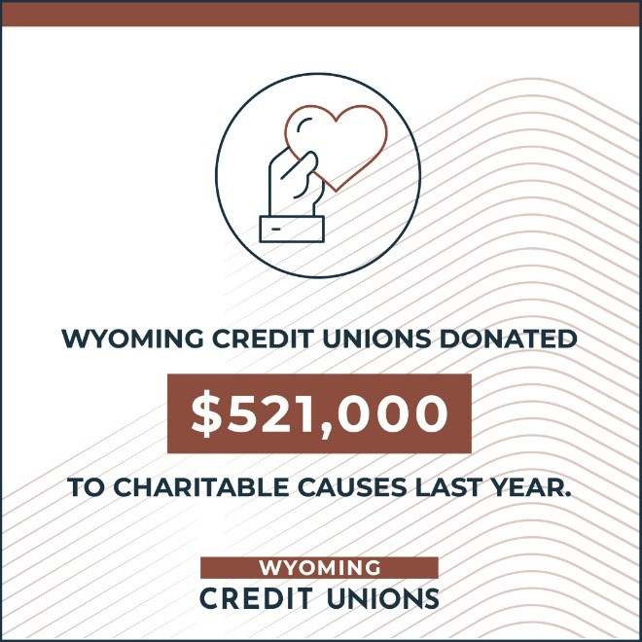
Twitter | Fact: 58% of Wyomingites belong to a credit union. That’s 336,000 people who received $36 million in direct benefits last year!  #CreditUnionDifference | 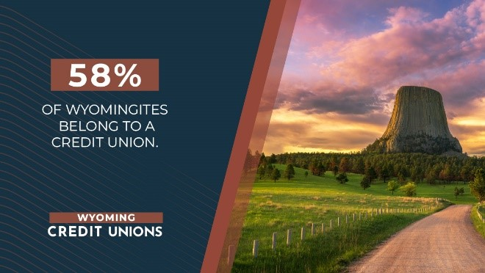
Twitter | Wyoming credit unions provided financial education to more than 10,000 Wyoming citizens, offering members and nonmembers alike the opportunity to achieve financial security.  #CreditUnionDifference | 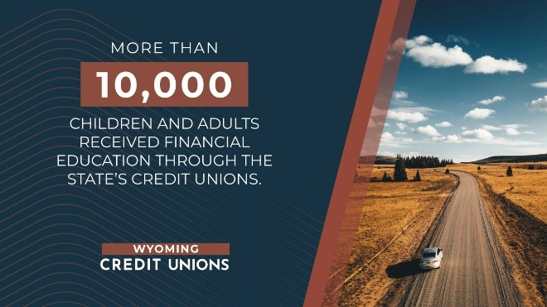
Twitter | Wyoming credit unions give back to our communities, especially when times are tough. Last year, Wyoming credit unions donated $521,000 to charitable causes. We’re proud of the #CreditUnionDifference! | 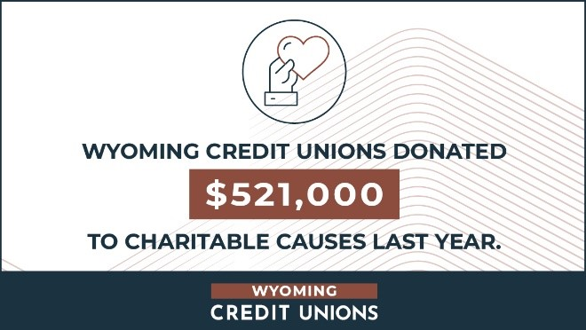
Twitter | Credit unions' not-for-profit,  cooperative structure inherently holds them accountable to the  member-owners they serve. #CreditUnionDifference | 