2022 GoWest/ECONorthwest Social Media Posts

WASHINGTON

Platform(s) | Message | Visual
Facebook | It’s no surprise that 58% of Washingtonians belong to a credit union. Members receive direct benefits, like lower loan interest rates, higher savings interest rates and reduced fees, totaling $424 million returned to members in direct benefits.  That’s the #CreditUnionDifference! | 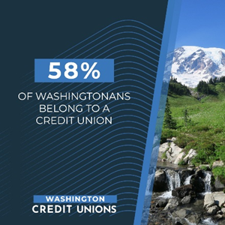
Facebook | “People Helping People” is the credit union mission. Credit union jobs have a positive ripple effect in the state by supporting additional jobs. Washington credit unions account for 12,000 jobs, and in turn, credit union operations support a total of 32,000 jobs in the state. | 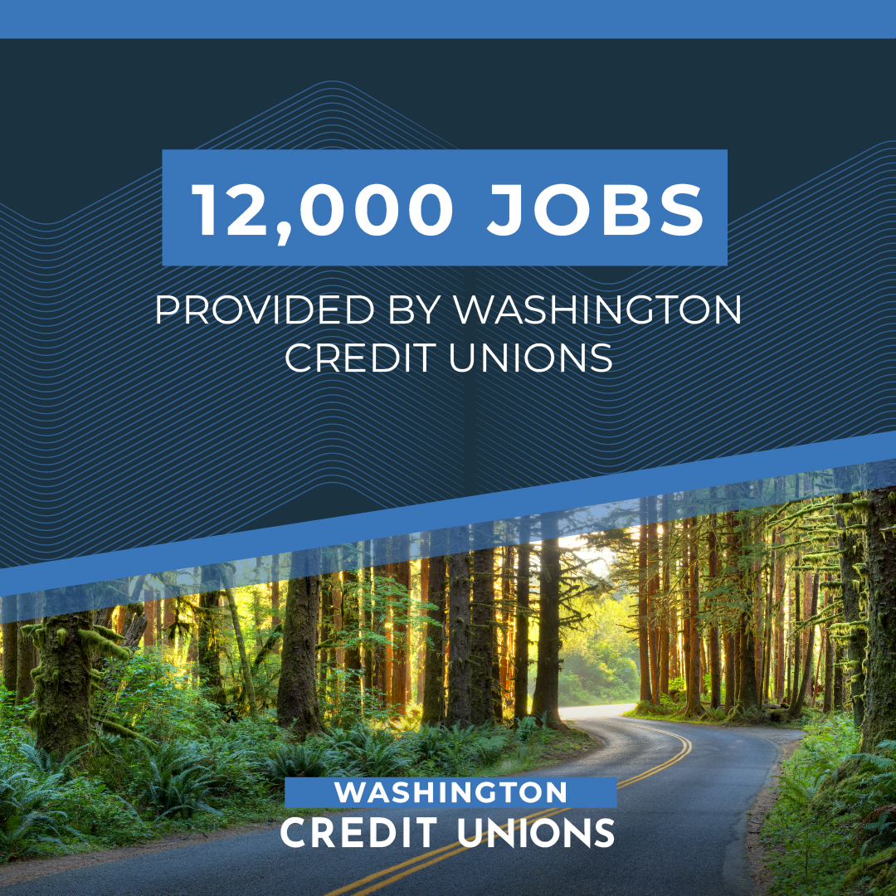
Twitter | Fact: 58% of Washingtonians belong to a credit union. That’s 4.51 million people who received $424 million in direct benefits last year!  #CreditUnionDifference
Twitter | Washington credit unions make a positive impact on Washington’s economy. The state’s 4.5 million credit union members received $424 million in direct member benefits which contributes to an economic ripple effect. #CreditUnionDifference | 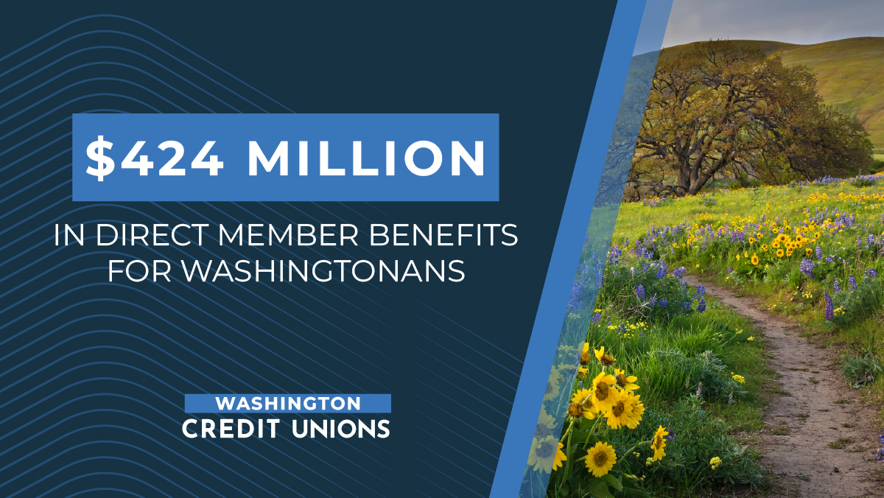
Twitter | Washington credit unions give back to our communities! Last year Washington credit unions volunteered more than 37,000 hours with nonprofits in our communities. #CreditUnionDifference
Twitter | Washington credit unions account for 12,000 jobs, impacting our state’s economy. In turn, credit union operations support a total of 32,000 jobs in the state. That’s the #CreditUnionDifference! | 