2022 GoWest/ECONorthwest Social Media Posts for
Oregon

OREGON

Platform(s) | Message | Visual
Facebook | We’re committed to keeping Oregon communities strong — especially when times are tough. Oregon’s 2.3 million credit union members received $203 million in direct member benefits which contributes to an economic ripple effect. #CreditUnionDifference | 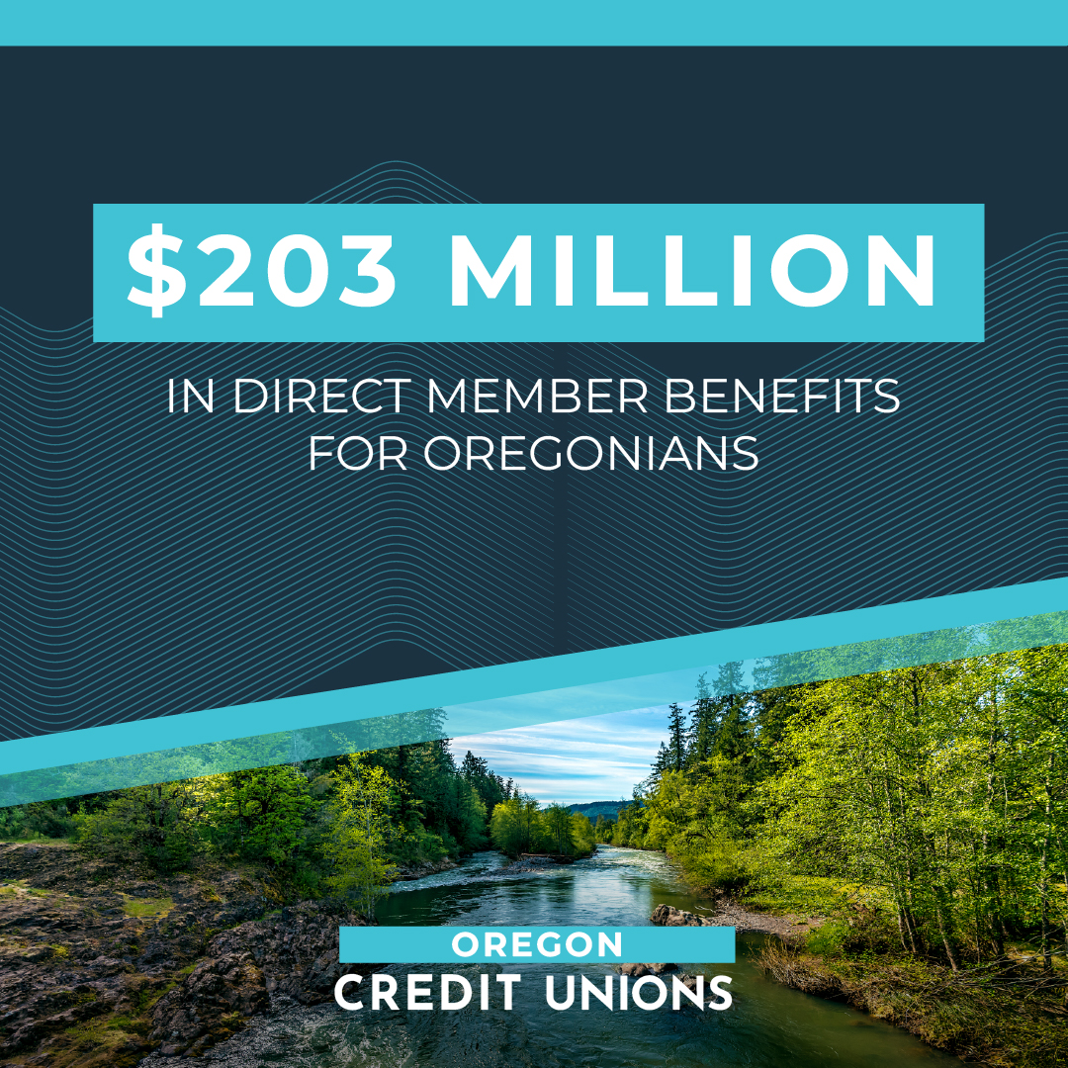
Facebook | More than 2.3 million Oregonians choose credit unions as their preferred financial services partner. That’s 55% of the population! Those members enjoy the perks of membership, including $203 million they received in direct member benefits last year. | 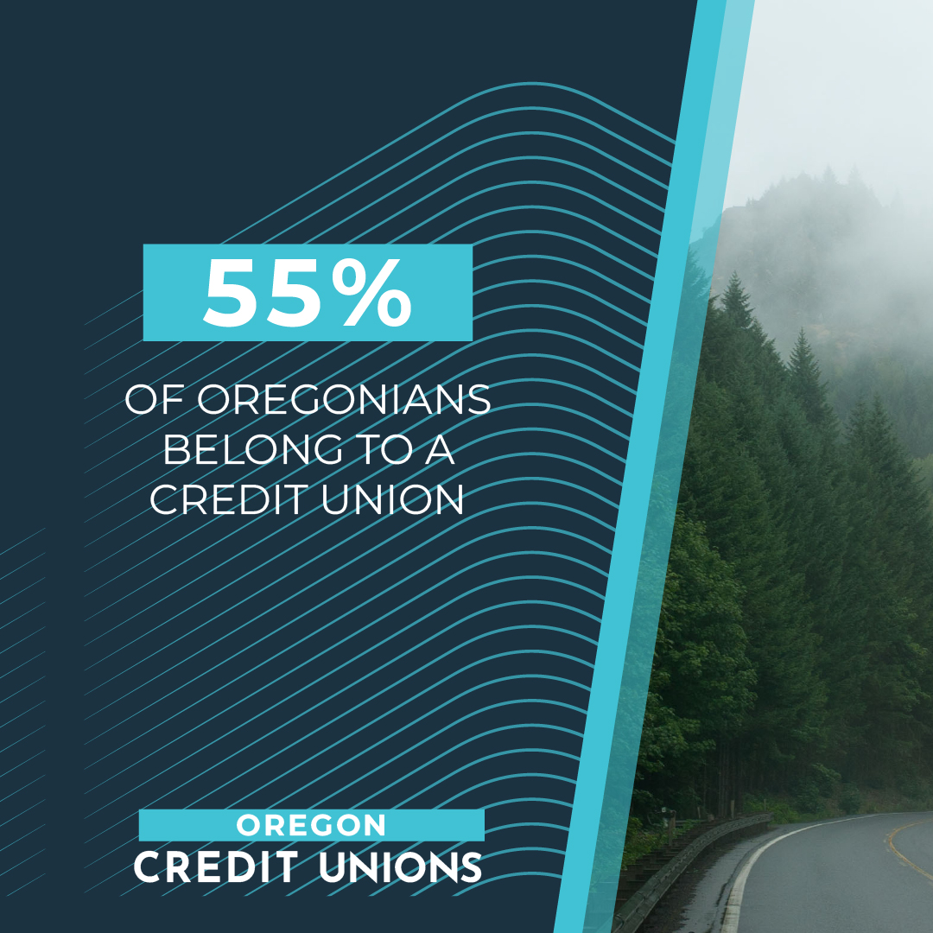
Facebook | Our “People Helping People” philosophy trickles down into everything we do. Oregon credit union employees connect with their communities, working side-by-side for charitable causes. We’re proud to be part of the #CreditUnionDifference! | 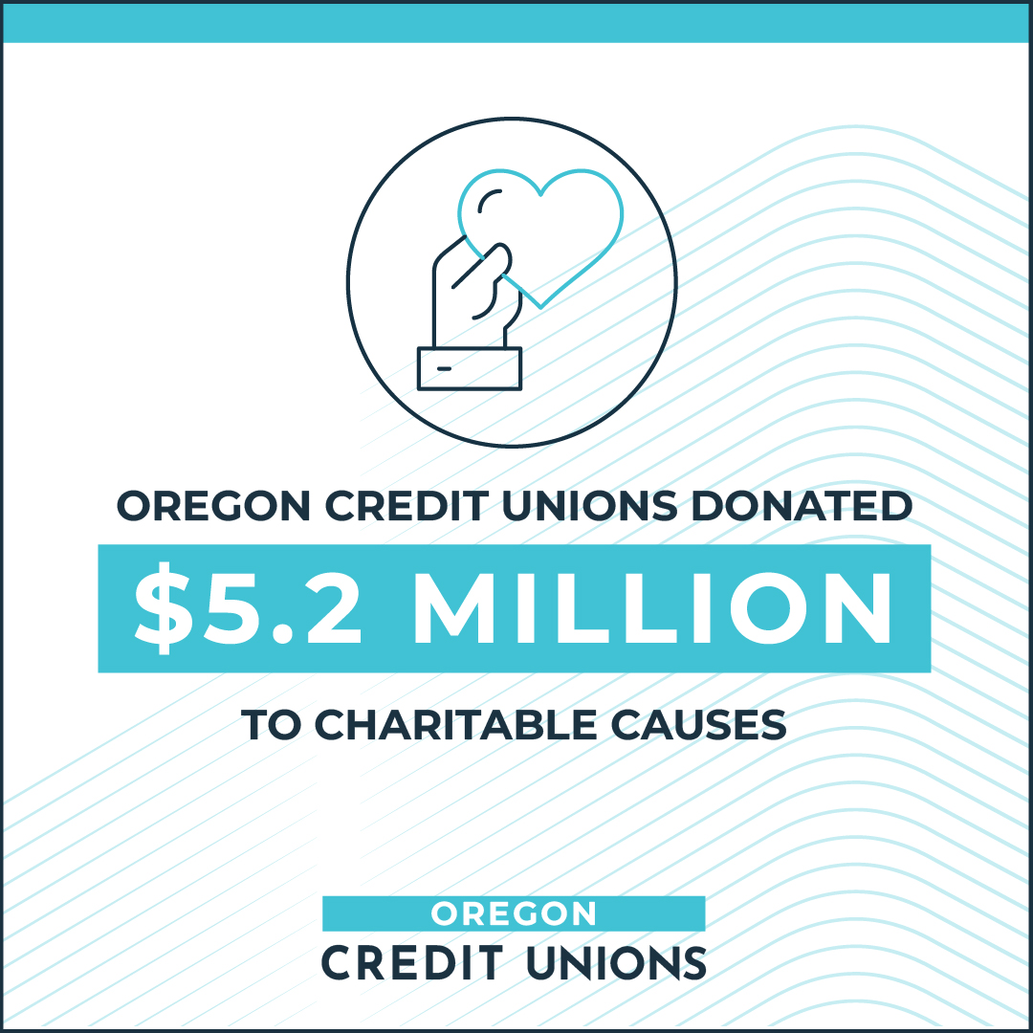
Twitter | No doubt, Oregonians are experiencing challenging economic times. Oregon’s credit union 2.3 million members enjoyed financial security through $203 million in direct benefits last year. #CreditUnionDifference | 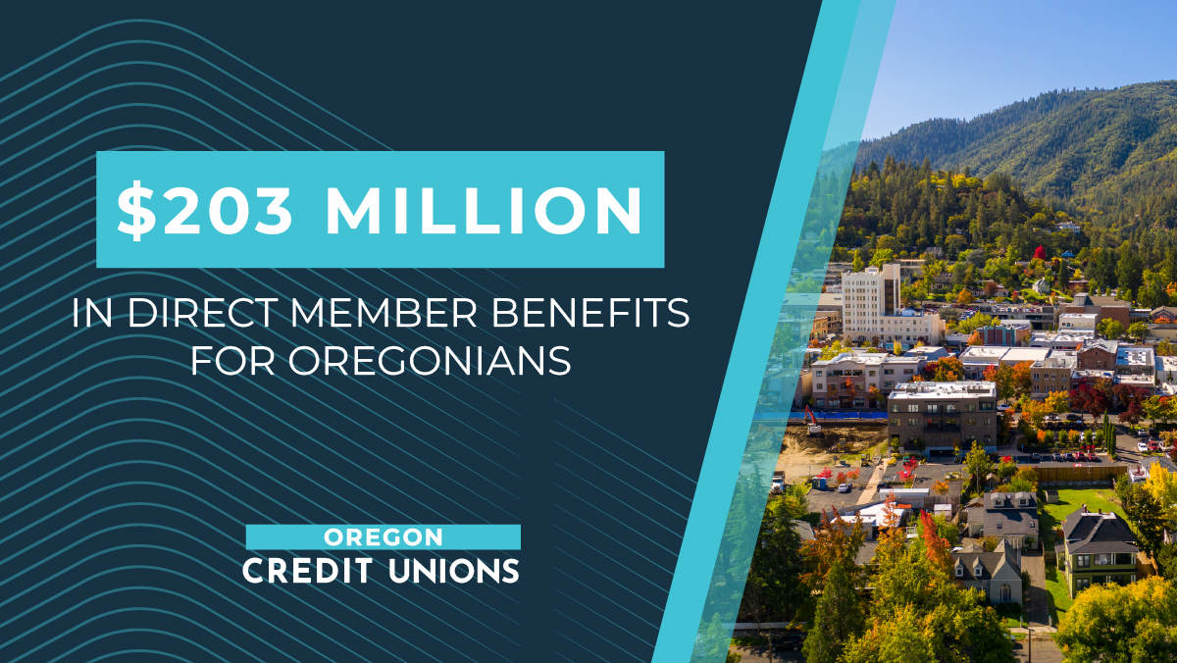
Twitter | We’re committed to keeping Oregon communities strong — especially when times are tough. Oregon’s 2.3 million credit union members received $203 million in direct member benefits which contributes to an economic ripple effect. #CreditUnionDifference

