Here are a few insights I picked up from the sessions:

- Starting a meeting by everyone sharing an accomplishment with the room. Maybe a recent accomplishment or something they were proud of?

- Learning and growing means experiencing discomfort. Discomfort could become the goal because it means you are progressing.

- Credit unions need to create Financial Wellness events such as seminars and webinars on topics such as saving, budgeting, and investing…. ***Well that was cool to hear, doing these kinds of events around Tucson and surrounding is a big part of my role as partner alliance officer. I was able to share how I structure my seminars/webinars and it was a great discussion.

- Instead of thinking of your sales not progressing and considering yourself a “failure,” consider the sales tactic used as a “failed attempt.” Tweak and practice sales and learn from every “failed attempt.”

- Empower the next generation of leaders by looking within your organization.

- Talent retention tips -> many employees now value connection above most things, new relationships, new bonds, being understood, values alignment within the organization or department, and feeling connected to the organization. If employees feel disconnected they are more likely to leave. Evolving our values to appeal to and empower the next generation. It was recommended to have 30 minutes per month of meetings with the top leaders within the credit union.

- Authentic mentoring within the organization plus -> 94% of employees would stay at a company longer if it invested in their learning and development.

- Career paths have now become skill paths. Taking account of what skills have been learned by each role and considering skill paths when designing roles.

- 50% of employees find meaning in their work today. Employee retention is always challenging because you are starting off with half of employees somewhat disconnected or not engaged. They wanted us to think back to the previous presentation and consider employee retention mishaps as “failed attempts” rather than a failure.

- Sales, persuasion, and helping others take action with proper information:

Want to persuade anyone? Use the rule of 3 to be in the top 1%. Whenever you are trying to persuade someone to do something: present 3 reasons, not 1, not 4, but 3 reasons exactly. The argument gets their attention and is more memorable, human psychology is wired to expect things in groups of 3. If you are asked, “why should we do this?” Respond with, “there are 3 reasons why we should do this.” You get their attention and more information is absorbed. You are forced to choose the 3 most important reasons, and deliver the 3 reasons that will have the highest effect. The world is drowning with information abundance, choose your 3 most powerful arguments wisely. Using the rule of 3, you sound more persuasive, structured, and confident. You are forced to: cut the fat, inspire confidence, and focus on what moves the needle.

- Speed is the ultimate weapon in business -> Using this process to grow and move 10 times faster. Increase your learning speed -> spend more time learning, build an experiment engine to try and test new ideas, remember what you learn to implement across your life, set a cadence that everyone has to react to, be member-focused vs competitor-focused, and be proactive rather than reactive. Compound small gains -> little gains compound into large gains over time. Quickly iterate from any and all feedback received.

- Becoming a better communicator and using the 3-step process to communicate with the best -> Start with the answer first, it is natural to build up to a conclusion after presenting the facts, instead, give the answer first. This allows your listener to quickly process your recommendation. When “What should we do?” is asked, answer with, “You should do X.” You’ll be more persuasive. Group and summarize your supporting arguments. Your ideas should form a pyramid under your answer. Your ideas at one level must be a summary of ideas below. For each supporting argument, break down into a group of 3. Three is the magic number, memorable and persuasive. Logically order your supporting ideas because you want to make sure your ideas belong together. Time order -> follow if there is a sequence of events, structural order -> break a single thought into its parts, and degree order -> present your ideas from most to least important. To summarize, start with the answer first, group and summarize your supporting arguments, and logically order your supporting ideas. Chart below:

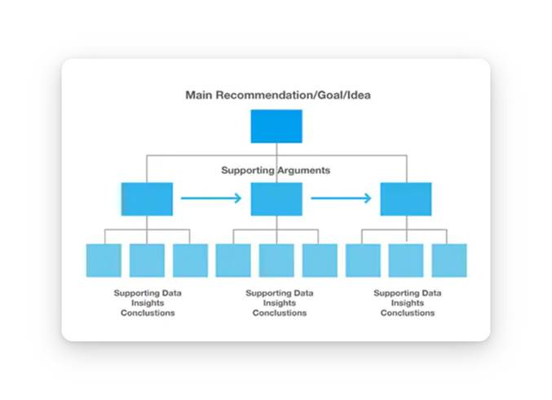
- I did a lot of networking and we got to meet with credit union vendors from all walks of life including website management, mobile apps, financial technology, digital security, cash management, credit union rewards programs, you name it. My WCUC app has all of their contact information.

My main takeaway from this whole event was that credit unions are making an enormous impact on the daily lives of our members worldwide. The difference in cost savings between credit unions and banks can range from minor savings to huge savings. I gave the example of our credit card rates during a discussion about what everyone thought about the impact that credit unions were having.

This is a small example, but it illustrates a big part of the difference we are making. Our Visa Gold card is currently sitting at 10.9% Annual Percentage Rate versus the average national credit card rate of 21.33% APR. That is a noticeable difference that has helped our members immensely. I’m sure we have all done balance transfers for members out of their current 30% interest credit cards, auto loans, and personal loans down to rates half of that or lower. Shaving off $300-$700 a month or more in monthly payments and putting money directly back into our member's pockets. This will sound corny but a big enough improvement in our member's monthly cash flow is legitimately life-changing because it can improve their financial wellness, relieve stress, and increase their ability to create emergency fund savings.

